**FLOOD PREDICTION AND ALERT SYSTEM**

**A PROJECT REPORT**

***Submitted by***

***Aman Jha(22BIT70031)***

***Raunak(22BIT70008)***

***In partial fulfilment for the award of the degree of***

***Bachelor of Engineering***

***IN***

***Internet of Things (IoT)***



**Chandigarh University**

**Session: APRIL 2025**



**BONAFIDE CERTIFICATE**

Certified that this project report “**Flood Prediction and Alert System**” is the Bonafide work of Aman Jha who carried out the project work under my supervision.

SIGNATURE SIGNATURE

Abhishek Tiwari Dr. Aman Kaushik

SUPERVISOR HEAD OF THE DEPARTMENT

AIT-CSE AIT-CSE

Submitted for the project viva voce examination held on 29.04.2025

INTERNAL EXAMINER EXTERNAL EXAMINER

**ACKNOWLEDGEMENT**

It gives us the privilege to complete this mid semester project. This is the only page where we have the opportunity to express my emotions and gratitude. It is a great pleasure in expressing sincere and deep gratitude towards my supervisor and guide Amandeep Kaur for her valuable suggestions, guidance, and constant support throughout the completion of this project named “**Flood Prediction and Alert System”**. This project though done by us, wouldn't be possible without the support of varied people, who by their cooperation have helped us in bringing out this project successfully. I am really very thankful to Chandigarh University for providing me such a great opportunity to make such a wonderful project which can solve real-life problems and extremely valuable hands on experience along with crucial soft skills such as working in a team, communication skills, and much more. I also offer my most sincere thanks to every team member of our group who was working rigorously on this project and staff members of the AIT-CSE Department, University Institute of Engineering, Chandigarh University for cooperation provided by them in every possible way. We thank all the faculty members and other supporting staff for the help they provided to us for the completion of our project.

Aman Jha

Raunak Kumar

(Student B.E. CSE-IoT, 6th Semester)

**TABLE OF CONTENTS**

**List of Figures .......................................................................................... 5**

**Abstract……………………..…………………………………………... 6**

**Graphical Abstract……………………………………………………... 7**

**Abbreviations………………………………………...…………………..8**

**CHAPTER 1. INTRODUCTION ….......................................................9**

* 1. Client Identification/Need Identification/Identification of

relevant Contemporary issue……………………………………………15

1.2. Identification of Problem …....................................................... .. 19

1.3. Identification of Task.....................................................................23

1.4. Timeline…………..........................................................................29

1.5. Organisation of the report: ….........................................................30

**CHAPTER 2. LITERATURE REVIEW/BACKGROUND STUDY.... 31**

2.1. Timeline of the Reported Problem …...............................................32

2.2. Proposed Solutions …......................................................................34

2.3. Bibliometric Analysis ..................................................................... 38

2.4. Review Summary………………… …............................................40

2.5. Problem Definition……………………………… …......................42

2.6. Goals / Objectives …………….......................................................43

**CHAPTER 3. DESIGN FLOW / PROCESS…………………………..44**

3.1. Evaluation & Selection of Specifications/Features………………….45

3.2. Design Constraints…………………………………………………..45

3.3. Analysis and Feature finalization subject to constraints……………..46

3.4. Design Flow…………………………………………………………46

3.5. Design Selection…………………………………………………….47

3.6. Implementation plan/Methodology…………………………………48

**CHAPTER 4. RESULTS ANALYSIS AND VALIDATION………….49**

4.1. Implementation of Solution………………………………………….49

**CHAPTER 3. CONCLUSION AND FUTURE WORK …...................57**

5.1. Future work …................................................................................57

5.2. Conclusion ….................................................................................58

**REFERENCES**

…........................................................................................... 59-60

**LIST OF FIGURES**

1. Graphical Abstract of Flood Prediction and Alert System……………7
2. Flood Representation………………………………………….……..10
3. River Flood…………………………………………………………..11
4. Flash Flood…………………………………………………………...11
5. Coastal Flood………………………………………………………...12
6. Urban Flood……………………………………………………….…12
7. Pluvial Flood…………………………………………………………13
8. Timeline of the Project……………………………………………….29
9. Workflow of the Project……………………………………………...47
10. Circuit Diagram of Project…………………………………………...49
11. Arduino UNO……………………………………………………….50
12. Ultrasonic Sensor (HC-SR04)………………………………………51
13. Water Level Sensor…………………………………………………52
14. 16x2 LCD Display Module…………………………………………53
15. Buzzer………………………………………………………………54
16. GSM-900……………………………………………………………55
17. Practical Representation of the Project……………………………..55
18. Flood Detection Screen…………………………………………….56
19. Alert System………………………………………………………..56

**ABSTRACT**

Flooding is a major natural disaster that poses significant risks to human life, infrastructure, and the environment. Traditional flood forecasting and warning systems often rely on historical data and manual processes, which may not provide timely or accurate predictions. This project aims to develop a real-time Flood Prediction and Alert System leveraging modern data analytics, machine learning (ML), and Internet of Things (IoT) technologies. By combining predictive analytics with real-time sensor data, this system seeks to enhance flood prediction accuracy and provide early warnings to mitigate potential damage.

The primary objective of this project is to create an integrated system capable of predicting floods based on environmental data and triggering alerts in real time. The system utilizes IoT sensors for continuous monitoring of key environmental factors such as water levels, rainfall, and soil moisture. These sensors are strategically placed in flood-prone regions to collect data, which is then transmitted to a cloud-based platform for processing. The system employs machine learning algorithms, particularly the Random Forest classifier, to predict flood events based on historical and real-time data. The model is trained using historical flood data, rainfall patterns, and water levels, and it is designed to predict the likelihood of flooding with high accuracy.

In addition to prediction, the system incorporates a robust alert mechanism that can send instant notifications to users, authorities, and emergency services in case of a flood prediction. Alerts are communicated through multiple channels, including SMS, email, and a mobile app, ensuring widespread and timely dissemination of information. The alert system not only warns the public of imminent flooding but also provides detailed information such as the severity of the flood and recommended actions for evacuation.

**GRAPHICAL ABSTRACT**

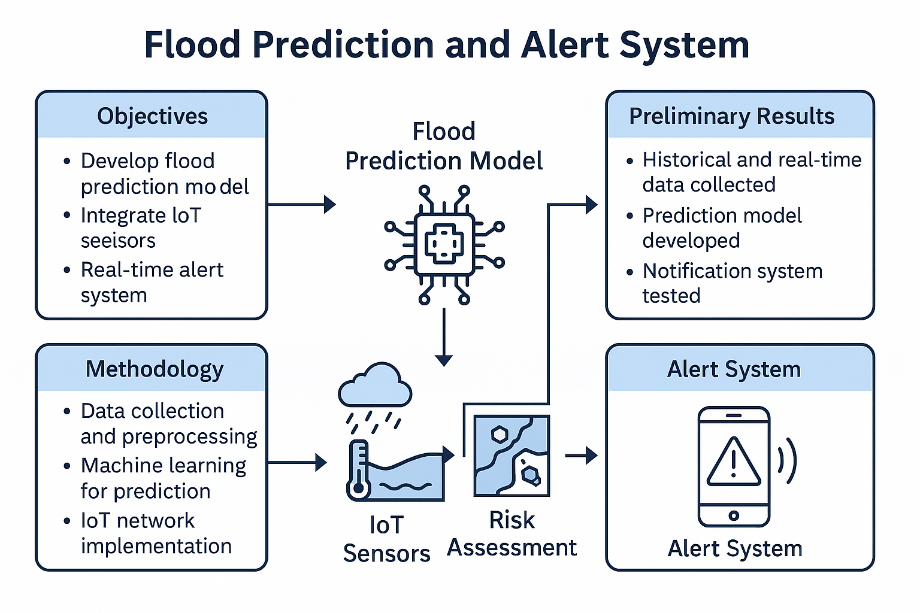

**Fig. 1.:** Graphical Abstract of Flood Prediction and Alert System.

**ABBREVIATIONS**

1. IoT = Internet of Things
2. ML = Machine Learning
3. AI = Artificial intelligence
4. GIS = Geographic Information Systems
5. API = Application Programming Interface
6. GPS = Global Positioning System
7. RF = Random Forest
8. LSTM = Long Short-Term Memory
9. CNN = Convolutional Neural Network
10. CPU = Central Processing Unit
11. GPU = Graphics Processing Unit
12. AWS = Amazon Web Services
13. DB = Database
14. HTTP = HyperText Transfer Protocol
15. MQTT = Message Queuing Telemetry Transport
16. PCA = Principal Component Analysis
17. ROC = Receiver Operating Characteristic
18. AUC = Area Under Curve
19. RNN = Recurrent Neural Network
20. CSV = Comma-Separated Values
21. SVM = Support Vector Machine
22. WSN = Wireless Sensor Network
23. ANN = Artificial Neural Network
24. FTP = File Transfer Protocol
25. ERP = Emergency Response Plan
26. DRR = Disaster Risk Reduction
27. DSS = Decision Support System
28. LAN = Local Area Network
29. WAN = Wide Area Network
30. QoS = Quality of Service
31. IoMT = Internet of Medical Things
32. LED = Light Emitting Diode

**CHAPTER 1**

**INTRODUCTION**

Floods are among the most frequent and devastating natural disasters worldwide, causing extensive damage to life, property, agriculture, and infrastructure. With increasing urbanization, deforestation, and the effects of climate change, the frequency and intensity of floods have significantly risen. Traditional flood monitoring and warning systems often suffer from delayed data collection, limited real-time monitoring capabilities, and insufficient predictive accuracy, leading to inadequate disaster preparedness and response.

To address these challenges, the integration of modern technologies such as **Internet of Things (IoT)**, **Machine Learning (ML)**, and **Data Analytics** presents a promising solution. IoT sensors allow for continuous, real-time monitoring of environmental parameters like water level, rainfall intensity, soil moisture, and river flow rates. Meanwhile, machine learning algorithms can analyze historical and real-time data to predict flood events with greater accuracy and speed than traditional models.

The **Flood Prediction and Alert System** aims to combine these advanced technologies to create a robust, scalable, and real-time flood forecasting solution. IoT-based sensor networks will collect live environmental data, which will be transmitted to a cloud-based platform for processing. Machine learning models, trained on historical flood and weather data, will analyze the incoming sensor data to predict potential flooding events. Once a threat is detected, the system will trigger automatic alerts to concerned authorities, emergency services, and the public via SMS, email, and mobile applications, ensuring timely evacuations and damage control measures.

This project not only focuses on real-time flood prediction but also emphasizes early warning dissemination, risk mapping, and community awareness, aiming to reduce the loss of life and economic impact caused by floods. By leveraging modern technologies and data-driven insights, this system seeks to revolutionize the traditional flood management infrastructure and build more resilient communities.

In this context, the **Flood Prediction and Alert System** offers a powerful tool for proactive disaster management, combining **predictive analytics**, **sensor technologies**, and **automated alert systems** into an integrated platform. The implementation of this system is expected to contribute significantly to disaster risk reduction (DRR) and enhance the capacity of authorities to respond effectively to flood events.

Floods are natural hydrological phenomena characterized by the overflow of water onto land that is usually dry. They occur when the volume of water in a river, lake, or ocean exceeds its normal limits, or when precipitation exceeds the land's capacity to absorb it. Floods are influenced by complex interactions among meteorological, hydrological, geological, and anthropogenic factors, making their prediction and management a challenging scientific problem.

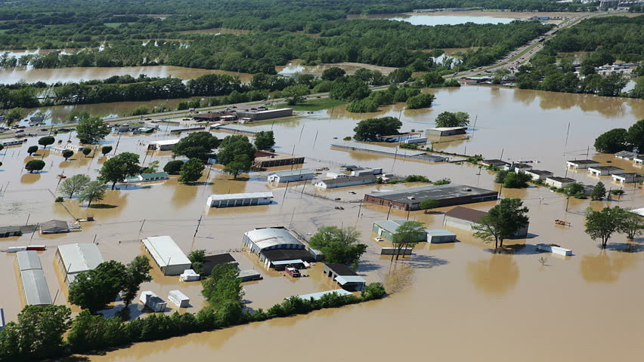

**Fig.2.:** Flood Representation

**Types of Floods:**  
Floods can be broadly categorized into several types:

* **River Floods** occur when rivers overflow their banks due to prolonged rainfall or snowmelt.

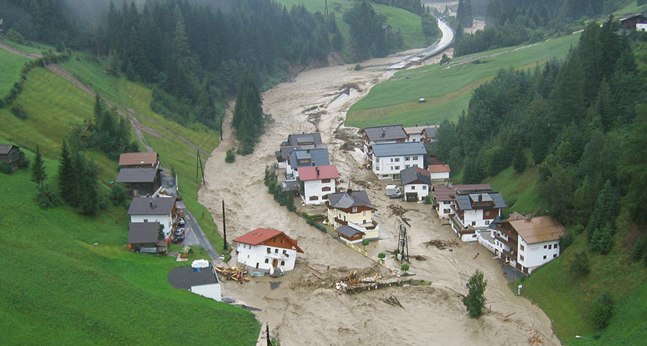

**Fig.3.:** River Flood

* **Flash Floods** are sudden, intense floods resulting from heavy rainfall over a short period, often exacerbated by poor drainage or urban infrastructure.

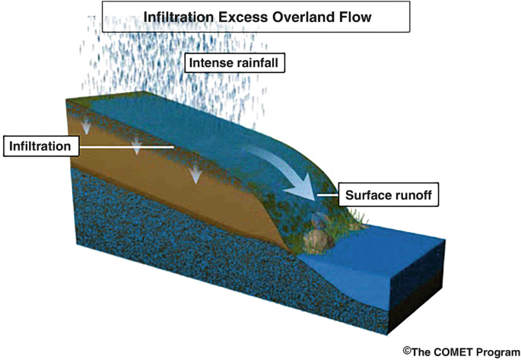

**Fig.4.:** Flash Flood

* **Coastal Floods** are caused by storm surges, high tides, or tsunamis pushing seawater inland.

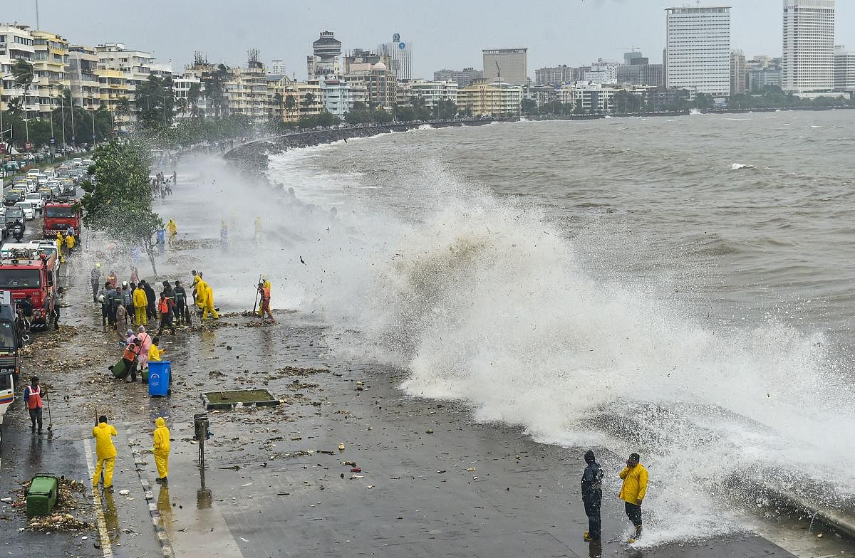

**Fig.5.:** Coastal Flood

* **Urban Floods** result from drainage failures during intense rainfall in cities.

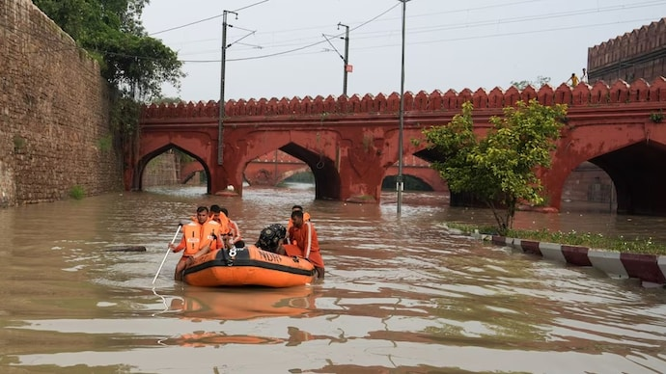

**Fig.6.:** Urban Flood

* **Pluvial Floods** are due to direct heavy rainfall accumulation in areas not necessarily near water bodies.

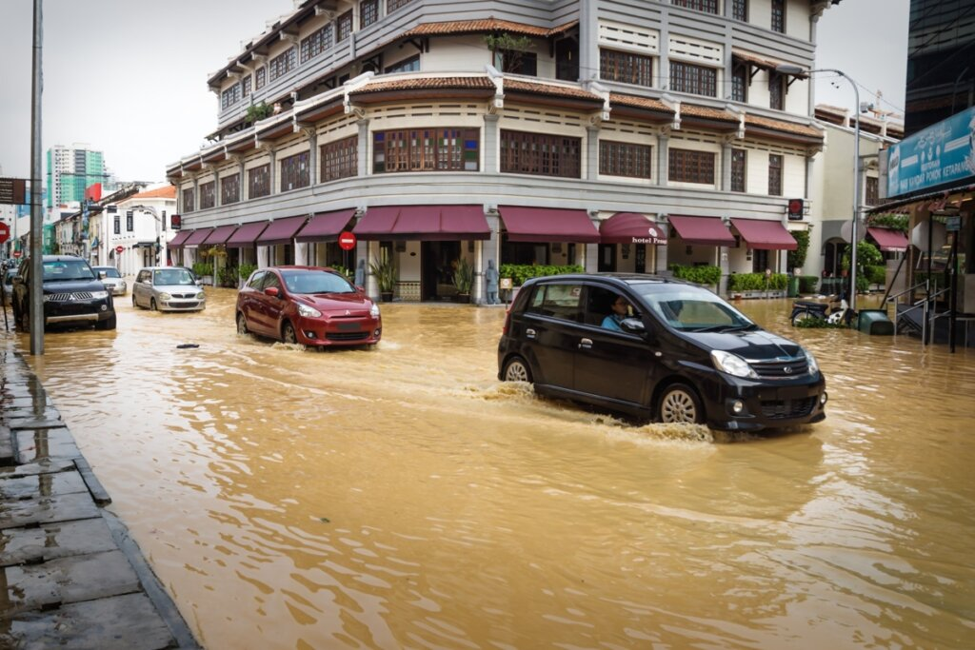

**Fig.7.:** Pluvial Flood

**Causes of Floods:**  
Flooding can arise from natural causes like heavy rainfall, rapid snowmelt, hurricanes, and tsunamis. Human activities such as deforestation, unplanned urbanization, destruction of wetlands, and poor land-use practices significantly increase the frequency and severity of floods. Climate change has further intensified these natural cycles, resulting in more unpredictable and extreme flood events globally.

**Hydrological Processes:**  
Floods are governed by several hydrological processes, including precipitation, infiltration, surface runoff, groundwater flow, and river discharge. When rainfall intensity exceeds the soil's infiltration capacity, excess water flows overland, contributing to surface runoff. This runoff accumulates in rivers and streams, and if the carrying capacity is exceeded, flooding occurs.

Key hydrological parameters affecting floods include:

* Rainfall intensity and duration
* Catchment area characteristics (slope, soil type, vegetation cover)
* River channel capacity and condition
* Groundwater levels and soil saturation
* Storage structures like dams and reservoirs

**Flood Modelling and Prediction:**  
Flood forecasting requires understanding the relationship between rainfall and runoff within a catchment. Mathematical models simulate these relationships using historical data, real-time inputs, and physical laws.  
Common approaches include:

* **Empirical models**, which use historical correlations.
* **Hydrological models**, which simulate rainfall-runoff processes.
* **Hydraulic models**, which simulate the movement of floodwaters through river systems and urban drainage networks.
* **Machine Learning models**, increasingly popular, that identify complex patterns from large datasets for improved predictive accuracy.

Modern flood prediction also incorporates Geographic Information Systems (GIS) and Remote Sensing to monitor changes in land use, topography, and water bodies.

**Flood Impact and Risk Management:**  
Floods can devastate human lives, agriculture, infrastructure, and economies. Flood risk management involves not only prediction but also preventive and mitigative measures such as:

* Building levees, embankments, and retention basins.
* Implementing early warning systems.
* Promoting sustainable land use and afforestation.
* Raising community awareness and preparedness
  1. **Client Identification/ Need Identification/ Identification of relevant Contemporary issue**

The primary clients for the Flood Prediction and Alert System are:

* **Government Agencies:** Disaster Management Authorities, Meteorological Departments, and Urban Planning Departments that require accurate and timely flood forecasting for effective decision-making and resource mobilization.
* **Emergency Services:** Fire and Rescue Departments, Police, Medical Services, and Evacuation Teams that need real-time alerts to act swiftly in flood-prone regions.
* **Local Communities:** Residents living in flood-vulnerable areas who need early warnings to prepare and evacuate safely.
* **NGOs and Environmental Organizations:** Institutions involved in disaster relief, community awareness programs, and infrastructure rebuilding post-disaster.
* **Insurance Companies:** Organizations that can use accurate flood prediction data for claims management and risk assessment.
* **Educational and Research Institutions:** To study and develop improved flood forecasting models.
* **Travel and Tourism Industry:** To warn travelers and protect tourism hotspots.
* **Public Transportation Departments:** Railways, metro systems, and airports that can face operational disruptions due to floods.
* **Infrastructure and Construction Companies:** To assess flood risks in design and construction stages.
* **Smart City Projects:** Integrating real-time flood monitoring into smart infrastructure.

Floods result in massive economic losses, displacement of populations, and loss of life. The critical needs identified are:

* **Real-Time Monitoring**: There is a lack of continuous, automated monitoring systems for environmental parameters such as water levels, rainfall, and soil saturation.
* **Accurate Early Warning Systems**: Existing flood forecasting models often provide delayed or inaccurate predictions, leading to unpreparedness.
* **Data-Driven Decision Support**: Authorities need actionable insights based on real-time and historical data to plan evacuations and resource allocation effectively.
* **Community Preparedness**: People living in flood-prone areas require easy-to-access, reliable alerts to prepare or evacuate timely.
* **Risk Mapping and Assessment**: There is a need for detailed flood risk maps to identify vulnerable areas and plan infrastructure accordingly.
* **Rapid Urban Flooding:** Especially in metro cities where drainage systems are unable to handle extreme rainfall events.
* **Resource Optimization:** Ensuring emergency resources (boats, shelters, rescue teams) are pre-positioned based on predictive analytics.
* **Data Fusion:** Combining data from sensors, satellites, weather forecasts, and historical databases for better predictions.
* **Customized Alerts:** Sending location-specific warnings to different categories of users (citizens, officials, first responders).
* **Infrastructure Protection:** Protecting critical infrastructures like power grids, hospitals, and communication networks during floods.
* **Post-Flood Analysis:** Using collected data to better design flood defenses and community planning.
* **Cost Reduction:** Preventing loss of life and minimizing economic damage through preventive measures.

Thus, a modern, integrated system that uses IoT, Machine Learning, and Data Analytics is essential to bridge the gap between flood prediction and early action.

Floods have become an increasingly **relevant contemporary issue** due to:

* **Climate Change**: Rising global temperatures have altered rainfall patterns, leading to unpredictable and more intense floods.
* **Urbanization**: Unplanned urban growth, particularly near rivers and coastal areas, has worsened flood risks due to poor drainage and reduced natural absorption of water.
* **Deforestation and Land Use Changes**: Decreased vegetation cover has increased runoff, leading to more frequent flash floods.
* **Infrastructure Vulnerabilities**: Aging or insufficient flood control infrastructure (such as dams and levees) is inadequate to handle new levels of flood intensity.
* **Inadequate Traditional Warning Systems**: Manual and outdated forecasting techniques are unable to cope with the speed and complexity of modern flood events.
* Global Warming: Leading to sea-level rise and heavier monsoon systems.
* Unpredictable Weather Events: Weather patterns have become more erratic, making traditional models obsolete.
* Digital Divide: Not all communities have access to timely information; thus, automated, multi-platform alert systems are crucial.
* Rise of Smart Cities: Need for real-time environmental monitoring fits perfectly with IoT-driven flood alert systems.
* Policy Pressure: Governments are under increasing pressure to meet international frameworks like Paris Agreement, UN SDGs, and Sendai Framework for Disaster Risk Reduction.
* Public Health Risks: Flooding leads to secondary disasters like water-borne diseases, which need to be prevented.
* Insurance and Finance Sector: Demand for accurate flood predictions for underwriting policies and disaster bonds.
* Ecosystem Disruption: Floods not only impact humans but also disturb wildlife habitats, making early warnings important for conservation.
* Increased Litigation: In some countries, authorities face lawsuits for flood damages if they fail to issue timely warnings — making predictive alert systems a legal necessity.

In view of these issues, developing a smart Flood Prediction and Alert System is a contemporary technological necessity, aligning with the goals of Sustainable Development Goals (SDG 11: Sustainable Cities and Communities) and Disaster Risk Reduction frameworks like the Sendai Framework.

* 1. **Identification of Problem**

Floods are among the most common and devastating natural disasters, affecting millions of people worldwide every year. Despite advancements in technology, the prediction, management, and response to flood events continue to face significant challenges. The identification of the key problems that this project addresses is crucial for understanding the need for an intelligent and real-time Flood Prediction and Alert System.

**1. Inadequate Real-Time Monitoring**

Traditional flood monitoring systems often rely on manual observations or delayed data reporting. In many regions, data such as rainfall levels, river heights, and soil moisture are collected manually and updated infrequently. This lack of real-time monitoring leads to significant delays in detecting flood risks, preventing timely evacuation and response.

Additionally, there is a limited use of automated sensor networks in many flood-prone areas. Without continuous, real-time monitoring, early warning systems are ineffective, and communities are left vulnerable to sudden flood events.

**2. Limited Predictive Capabilities**

Existing flood prediction models are often based on statistical or hydrological models that depend heavily on historical data. While useful, these models are limited in their ability to adapt to the complex, dynamic conditions that characterize modern flood events. Factors such as rapid urbanization, changing weather patterns due to climate change, and land use alterations are not always accurately captured.

Moreover, these models often fail to integrate multiple data sources (such as real-time rainfall data, river gauge readings, satellite imagery, and soil saturation levels), resulting in incomplete or inaccurate predictions.

**3. Lack of Data Integration and Analysis**

Flood events are influenced by numerous factors — meteorological, hydrological, geographical, and human-induced. However, current systems struggle to integrate diverse data sources effectively. Real-time sensor data, weather forecasts, GIS data, and historical flood information are often siloed across different organizations.

Without proper data fusion and advanced analytics, critical patterns may be missed. The absence of Machine Learning (ML) and Artificial Intelligence (AI) techniques in traditional systems means that the ability to recognize complex patterns and predict floods accurately is severely limited.

**4. Poor Communication and Alert Dissemination**

Even when flood risks are detected, disseminating timely and clear alerts to the relevant stakeholders remains a major issue. Traditional methods like sirens, radio broadcasts, or local announcements often fail to reach all affected populations, especially in remote areas.

Furthermore, many warning systems do not personalize alerts based on geographical risk, leading to either mass panic (due to general warnings) or apathy (due to frequent false alarms). There is a clear need for a targeted, multi-channel communication system that can send accurate, location-specific warnings via SMS, mobile applications, emails, and public displays.

**5. Low Community Awareness and Preparedness**

Many people living in flood-prone areas are unaware of the risks or do not know how to respond effectively to early warnings. Inadequate public education, insufficient community drills, and a general mistrust of authorities contribute to poor disaster preparedness.

Additionally, without frequent drills or well-defined evacuation plans, even accurate flood predictions may fail to prevent casualties and damages because people do not act quickly or appropriately when warnings are issued.

**6. Climate Change and Unpredictability**

Climate change has made flood prediction even more complex. Rising global temperatures have altered rainfall patterns, leading to more intense storms, unpredictable monsoon seasons, and rising sea levels. Traditional models calibrated to historical weather data are increasingly unable to cope with the new, more erratic behaviours of natural systems.

This unpredictability calls for advanced machine learning models that can learn from both historical patterns and adapt to emerging real-time trends to improve the reliability of flood forecasts.

**7. Urbanization and Land Use Changes**

The rapid expansion of cities, often without proper planning, has worsened flooding in urban areas. Construction over natural waterways, inadequate drainage systems, loss of green cover, and encroachments into floodplains increase both the frequency and severity of urban floods.

Traditional flood models do not account adequately for these anthropogenic changes, leading to underestimation of flood risks in rapidly growing urban centers. Updated, dynamic risk models that can incorporate real-time land use changes are urgently needed.

**8. Infrastructure Vulnerabilities**

Many flood control structures — dams, levees, reservoirs, drainage systems — are aging and often inadequately maintained. Failure of these structures during extreme weather events can lead to catastrophic floods.

Monitoring the health and performance of such infrastructure is critical but is often neglected due to lack of funds, technology, or awareness. Integrating infrastructure health monitoring into the flood prediction system can help in early detection of vulnerabilities.

**9. Economic and Social Impacts**

Floods cause severe economic losses by damaging homes, businesses, roads, crops, and utilities. Recovery from flood events can take years, severely impacting regional economies and increasing poverty rates. In vulnerable communities, the social fabric is also disrupted, with long-term consequences for education, health, and employment.

Without accurate and timely flood warnings, mitigation strategies cannot be deployed effectively, exacerbating the economic and social impacts.

**10. Technological Gaps**

While IoT, cloud computing, and AI technologies have advanced rapidly, their adoption in flood management remains limited. Many regions, particularly in developing countries, still depend on outdated systems due to financial, technical, or institutional barriers.

The lack of an integrated, scalable, and user-friendly platform that uses modern technologies for flood prediction and alerts is a major gap that this project seeks to address.

* 1. **Identification of Tasks**

The successful development and deployment of the **Flood Prediction and Alert System** involves the execution of multiple interconnected tasks. These tasks span the entire project lifecycle — from data collection to model development, system integration, alert dissemination, and user feedback management. Clearly identifying and organizing these tasks ensures systematic progress, resource optimization, and timely completion of project goals.

**1. Requirement Gathering and Problem Analysis**

The first task involves understanding the project requirements in detail. This includes:

* Studying existing flood prediction systems and their shortcomings.
* Identifying client expectations (e.g., government agencies, local communities).
* Gathering input on critical parameters such as prediction accuracy, alert timeframes, communication methods, and operational scalability.
* Defining clear objectives for the system, like real-time monitoring, high prediction accuracy, low false alarms, and rapid alert dissemination.

**2. Data Collection and Management**

Flood prediction heavily depends on the availability and quality of diverse datasets. Key tasks include:

* Collecting historical flood data, rainfall data, river water levels, and soil moisture records from government databases and research organizations.
* Integrating real-time data streams from IoT sensors, satellite imagery, weather APIs, and river gauges.
* Cleaning, preprocessing, and organizing data for modeling (handling missing values, outliers, noise).
* Building a centralized database management system for efficient storage and retrieval of large-scale environmental data.

**3. Design and Development of Prediction Models**

At the heart of the system lies the flood prediction engine. Essential tasks include:

* Selecting appropriate modeling techniques: statistical models, hydrological models, or machine learning algorithms (e.g., Random Forest, LSTM, CNNs for spatio-temporal data).
* Training and validating models on historical and real-time data.
* Tuning hyperparameters to optimize model performance.
* Performing cross-validation to ensure the model's robustness and generalization ability.

**4. System Architecture Design**

The next major task is designing the overall system architecture. This involves:

* Defining the flow of data from sensors to the central server to the user interface.
* Developing cloud-based or local server infrastructures to ensure scalability and fault tolerance.
* Integrating GIS platforms for dynamic flood risk mapping.
* Creating system modules like data acquisition, data analytics, model inference, alert generation, and logging.

**5. Development of Alert Mechanisms**

Once a flood event is predicted, timely communication is crucial. Tasks related to alert systems include:

* Designing multi-channel notification systems: SMS alerts, mobile app notifications, sirens, and emails.
* Customizing alerts based on user roles — different information granularity for citizens, first responders, and policymakers.
* Ensuring redundancy in alert systems (if SMS fails, app notifications should still work).

**6. User Interface and Mobile Application Development**

To ensure accessibility and usability, developing intuitive interfaces is essential. This includes:

* Creating mobile applications for Android and iOS platforms.
* Developing web portals displaying real-time flood risk maps.
* Incorporating dashboards for administrators to monitor system health and data streams.
* Ensuring user authentication and privacy protection.

**7. Testing and Validation**

Before deployment, rigorous system testing must be undertaken:

* Unit testing of individual modules.
* System integration testing to ensure all modules work together seamlessly.
* Simulated flood scenarios to test prediction accuracy and alert delivery speed.
* Usability testing with target user groups to refine the interface and functionalities.

**8. Deployment and Integration with Authorities**

Deployment tasks include:

* Hosting the system on secure servers with backup and disaster recovery plans.
* Integrating the alert system with local emergency services and municipal authorities.
* Conducting training sessions for emergency response teams and administrative users.

**9. Community Awareness and Education Programs**

To maximize the impact of the system, tasks related to community engagement are important:

* Organizing workshops and mock drills in flood-prone areas.
* Distributing educational materials explaining flood risks and the use of the alert system.
* Creating awareness campaigns through social media and local radio/TV.

**10. Monitoring, Maintenance, and Upgradation**

Post-deployment, continuous monitoring and updating are vital:

* Real-time monitoring of system performance, data flow, and model accuracy.
* Periodic maintenance of IoT sensors, servers, and software components.
* Updating the prediction models with new data to improve their performance over time.
* Scaling up system capabilities as user base and coverage area expand.
  1. **Timeline**

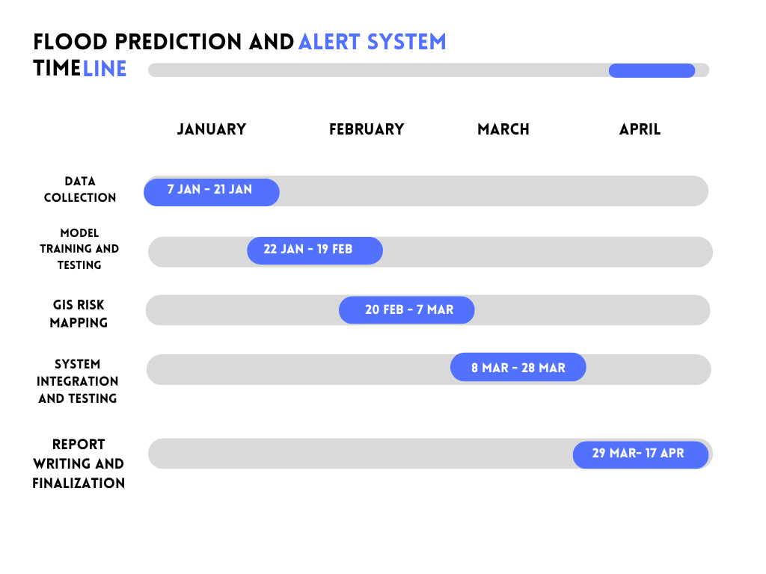**Fig.8.:** Timeline of the Project

* 1. **Organization of report**

**Chapter 1 Problem Identification:** This chapter introduces the project and describes the problem statement discussed earlier in the report.

**Chapter 2 Literature Review:** This chapter prevents review for various research papers which help us to understand the problem in a better way. It also defines what has been done to already solve the problem and what can be further done.

**Chapter 3 Design Flow/ Process:** The flow/process section of the research paper outlines the systematic steps undertaken to achieve the study's objectives. Initially, data collection methods, including sensors and GIS systems, are employed to gather relevant environmental data. Subsequently, machine learning models are applied to analyse the data, predict flood risks, and generate real-time alerts for effective mitigation strategies.

**Chapter 4 Results Analysis and Validation:** The results analysis and validation section presents the outcomes of the flood prediction model, comparing predicted flood events with actual occurrences to assess the model's accuracy. Performance metrics such as accuracy, precision, recall, and F1 score are calculated to evaluate the effectiveness of the machine learning algorithms used. Validation is further reinforced by cross-referencing predictions with real-world data from external sources, ensuring the reliability and robustness of the system.

**Chapter 5 Conclusion and future scope:** This chapter concludes the results and explain the best method to perform this research to get the best results and define the future scope of study that explains the extent to which the research area will be explored in the work.

**CHAPTER 2**

**LITERATURE REVIEW**

Flood prediction and early warning systems have been a critical area of research due to the devastating effects of floods on human life, infrastructure, and the economy. With the increase in extreme weather events due to climate change, accurate flood forecasting has become even more important. Traditionally, flood prediction relied on hydrological models that used physical data such as rainfall, river discharge, and historical flood records. However, these methods often had limited accuracy, especially in regions with sparse data or complex terrain.

Recent advancements have integrated machine learning (ML) techniques, which are particularly effective at identifying complex patterns in large datasets. ML models such as decision trees, neural networks, and support vector machines have been applied to predict floods by analyzing factors like rainfall intensity, soil moisture, and historical flood occurrences. These models can adapt and improve with more data, which makes them promising tools for real-time predictions.

Geographic Information Systems (GIS) play an essential role in flood prediction by providing spatial data that can be used to map flood-prone areas and model flood simulations. By integrating GIS with real-time sensor data from river gauges and weather stations, it becomes possible to monitor changes and provide more accurate flood forecasts.

Another key aspect of modern flood prediction systems is the alert mechanism. Automated notification systems using SMS, mobile apps, or email can significantly improve community preparedness and evacuation planning.

Despite these advancements, challenges such as data quality, sensor integration, and real-time processing remain. However, the ongoing research in combining ML, GIS, and sensor technologies shows great promise in enhancing the accuracy and reliability of flood prediction systems.

**2.1.** **Timeline of Reported Problem:**

**1. Early Recognition (Pre-20th Century):**

* **Floods as a Natural Hazard:** Historically, floods have been recognized as a recurring natural disaster, especially in areas near rivers or coastal regions. Early flood management relied heavily on physical barriers such as dikes and levees.
* **Lack of Early Warning Systems:** In ancient times, there were no reliable mechanisms to predict floods, leading to significant loss of life and property.

**2. Initial Studies and Data Collection (1900-1950):**

* **Basic Hydrological Studies:** Early hydrologists began studying river behavior, rainfall patterns, and water cycles, with limited scientific tools and methods. Flood forecasting remained rudimentary.
* **Limited Technology:** In this period, flood prediction was based mainly on visual cues like water levels and weather conditions, without advanced scientific instrumentation or predictive modeling.

**3. Technological Advancements and Modeling (1960-1980):**

* **Introduction of Hydrological Models:** The development of hydrological models, such as the Rational Method and SCS Curve Number, marked a significant step forward in flood prediction. These models were based on rainfall-runoff relationships but had limited accuracy and were highly dependent on local calibration.
* **Increased Meteorological Data Collection:** The establishment of more comprehensive weather stations improved the collection of rainfall and temperature data, offering some predictive value for flood events.

**4. Rise of Computer Modeling and Remote Sensing (1980-2000):**

* **Flood Prediction Models Improve:** The introduction of computer-based hydrological models, including the use of GIS (Geographic Information Systems) for mapping flood-prone areas, allowed for more sophisticated simulations and predictions.
* **Satellite Imagery:** The use of satellite imagery became more prevalent in flood monitoring, providing valuable data on land elevation, rainfall distribution, and water levels over large areas.
* **Remote Sensors and Real-Time Monitoring:** Early river gauges and weather stations began transmitting real-time data, offering the possibility for more timely flood predictions.

**5. Machine Learning and AI Integration (2000-Present):**

* **Machine Learning and Data Analytics:** In recent decades, the integration of machine learning algorithms has transformed flood prediction systems. Models like Random Forest, Support Vector Machines, and Neural Networks are now capable of identifying patterns in large datasets, such as weather forecasts, soil moisture, and river discharge data.
* **IoT and Sensor Networks:** Real-time data collection from an extensive network of sensors, including IoT devices, has made it possible to detect floods earlier and with greater precision.
* **Flood Prediction Apps and Alerts:** Modern systems now include automated alert mechanisms, such as SMS, email, and mobile app notifications, to warn communities about imminent flood risks.

**6. Current Challenges and Future Outlook (2025 and Beyond):**

* **Data Quality and Integration Issues:** Despite advances, challenges remain in the integration of diverse data sources (satellite imagery, weather data, river gauges) and ensuring their accuracy.
* **Real-Time Processing:** The need for real-time flood prediction systems that can operate effectively even under varying data availability and sensor malfunctions is still a major focus of ongoing research.
* **Resilience and Adaptation:** The future of flood prediction lies in building systems that are resilient to climate change, capable of handling increasingly volatile and unpredictable weather patterns.

**2.2. Proposed Solution**

The proposed solution is the development of an integrated Flood Prediction and Alert System that combines advanced Machine Learning (ML) techniques, Geographic Information Systems (GIS), real-time sensor data, and automated alert systems. This system aims to enhance flood prediction accuracy, provide timely warnings, and improve overall disaster management.

**Key Components of the Proposed Solution:**

1. **Data Collection and Integration:**
   * **Weather Data:** Real-time weather data from meteorological stations, including rainfall intensity, temperature, humidity, and wind speed.
   * **River Data:** Data from river gauge sensors to monitor water levels, flow rates, and velocity.
   * **Geospatial Data:** GIS data on topography, land elevation, flood-prone areas, and infrastructure layouts.
   * **Remote Sensing (Satellite Imagery):** Use of satellite imagery to assess flood-prone regions and track water bodies over large areas.
2. **Machine Learning Model for Flood Prediction:**
   * **Feature Engineering:** Extract meaningful features from the collected data (e.g., precipitation patterns, soil moisture, river discharge).
   * **Model Development:** Train machine learning models, such as **Random Forest**, **XGBoost**, or **Neural Networks**, to predict flood events based on historical and real-time data.
   * **Training and Validation:** Use historical flood data to train the model and evaluate its performance based on metrics like accuracy, precision, recall, and F1-score.
   * **Model Refinement:** Continuously improve the model as more data becomes available, ensuring it adapts to changing environmental conditions.
3. **Geographic Information Systems (GIS) Integration:**
   * **Mapping Flood-Prone Areas:** Use GIS for spatial analysis to identify and map areas at risk of flooding based on elevation data and historical flood events.
   * **Flood Simulation:** Integrate flood predictions with GIS to simulate potential flood scenarios in different regions, providing detailed insights into the extent and severity of floods.
4. **Real-Time Sensor Monitoring:**
   * **IoT Sensors:** Deploy IoT-based sensors to monitor real-time water levels, rainfall, and soil moisture. These sensors can feed data directly into the prediction system, providing real-time inputs for flood forecasting.
   * **Wireless Communication:** Ensure the real-time transmission of sensor data via wireless communication protocols to ensure timely updates and accurate predictions.
5. **Automated Alert System:**
   * **Alert Mechanism:** Develop an automated notification system that sends real-time flood alerts to authorities, local governments, and communities in flood-prone areas. Alerts can be delivered through multiple channels, including **SMS**, **email**, and **mobile apps**.
   * **Alert Triggering:** Alerts will be triggered when flood predictions exceed certain thresholds, such as water levels surpassing safe limits or rainfall intensity indicating imminent flooding.
   * **Public Awareness and Preparedness:** Integrate the alert system with public awareness campaigns to educate residents on flood risks, evacuation procedures, and safety measures.
6. **System Testing and Validation:**
   * **Model Evaluation:** Test the accuracy of flood predictions using historical flood data and simulate different flood scenarios.
   * **Sensor Validation:** Validate the accuracy and reliability of real-time sensor data in different weather conditions and geographical regions.
   * **Alert System Testing:** Perform tests to ensure that alerts are sent promptly and effectively reach the intended recipients.

**Benefits of the Proposed Solution:**

1. **Improved Prediction Accuracy:** The integration of machine learning and real-time data leads to more accurate flood predictions, reducing the chances of false positives or missed alerts.
2. **Timely Alerts:** The automated alert system ensures that affected communities are notified well in advance, enabling timely evacuations and disaster response.
3. **Risk Mapping:** GIS integration allows authorities to identify and prioritize flood-prone areas, enabling better planning for flood mitigation and resource allocation.
4. **Cost-Effective and Scalable:** The solution leverages existing technologies like IoT sensors and cloud computing, making it scalable and adaptable to different regions and budgets.
5. **Adaptability:** The system can evolve with changing environmental conditions by continuously improving its machine learning models and adapting to new data sources.

**Implementation Strategy:**

1. **Pilot Phase:** Implement the system in a flood-prone region to test its functionality and performance.
2. **System Optimization:** Refine the model and alert system based on the results from the pilot phase.
3. **Wider Deployment:** Once validated, expand the system to other flood-prone areas, with continuous updates and improvements based on user feedback and new data.

**2.3. Bibliometric analysis**

Bibliometric analysis is a method used to evaluate trends, research output, and the intellectual structure of a specific field. In the context of flood prediction and alert systems, bibliometric analysis helps identify key research themes, popular methodologies, influential publications, and collaboration networks within this area.

The main goal of conducting a bibliometric analysis for flood prediction and alert systems is to assess the growth and maturity of research in this field over time. It also helps to highlight the most common research methodologies, the leading journals, authors, and institutions contributing to this field, and identify gaps or emerging trends in flood prediction technologies. The analysis uses data collected from scientific databases such as Scopus, Web of Science, Google Scholar, IEEE Xplore, and Elsevier's ScienceDirect, which offer citation indexes and publication records. These databases provide insights into the number of publications, the frequency of citations, and important authors in the field.

A bibliometric analysis can also focus on identifying recurring keywords and research topics. Some of the common themes in flood prediction include flood forecasting, machine learning in flood prediction, the integration of Geographic Information Systems (GIS), real-time sensor networks, climate change and its impacts on flooding, flood risk mapping, artificial intelligence in disaster management, and the use of the Internet of Things (IoT) for flood monitoring.

One key aspect of bibliometric analysis is the examination of publication trends over time. The analysis typically reveals a significant increase in publications related to flood prediction over the past few decades, especially with the advancement of machine learning and sensor technologies. Major research milestones, such as the integration of machine learning with hydrological modeling or the use of satellite imagery in flood forecasting, can be identified as important breakthroughs.

Citation analysis is another crucial part of bibliometric analysis. It allows researchers to identify the most cited papers in the field. These papers might focus on topics such as integrating machine learning algorithms with hydrological modeling or the development of real-time flood prediction systems. Citation analysis also helps to uncover the key authors in the field, such as those specializing in hydrological modeling, AI in disaster prediction, or GIS and remote sensing for flood prediction.

In addition, bibliometric analysis can highlight the leading journals and conferences in this area. Some of the top journals where research on flood prediction and alert systems is published include the *Journal of Hydrology*, *Environmental Modelling & Software*, *Natural Hazards*, *Journal of Flood Risk Management*, and *IEEE Transactions on Geoscience and Remote Sensing*. Prominent conferences that often feature flood prediction and alert system research include the *International Conference on Flood Management (ICFM)* and the *IEEE International Conference on Communications, Control, and Computing Technologies for Smart Grids*.

The analysis can also provide insights into research collaboration networks. By mapping co-authorship data, bibliometric analysis can identify the institutions, universities, and research centers contributing to the field. Leading institutions in flood prediction research could include universities such as MIT, IIT Kharagpur, the University of Tokyo, and Stanford University. The analysis can also show international collaboration patterns, indicating which countries are most active in this area of research.

Furthermore, bibliometric analysis can help identify emerging trends and research gaps. For instance, it might reveal growing interest in using deep learning, big data analytics, and edge computing for real-time flood monitoring. The analysis may also highlight underexplored areas, such as multi-source data integration, scalability of prediction systems, flood impact prediction on communities, and the adaptation of flood prediction systems to the challenges posed by climate change.

To visualize and analyze bibliometric data, researchers often use tools like VOSviewer, which creates network visualizations of authors, journals, and keywords, or Gephi, which provides detailed collaboration networks. The Bibliometrix R package is also widely used for statistical analysis of bibliometric data and the creation of co-citation networks.

In conclusion, a bibliometric analysis of flood prediction and alert systems offers valuable insights into the evolution of the field, identifying strengths, weaknesses, and opportunities for further research. By examining publication patterns, citation networks, and institutional contributions, it can guide researchers toward new areas of exploration, inform the development of more accurate flood prediction technologies, and help refine flood risk management strategies.

**2.4. Review Summary**

Flood prediction and alert systems are essential tools for mitigating the devastating impacts of flooding, one of the most destructive natural disasters. Over the years, the field has evolved significantly, integrating new technologies like machine learning (ML), Geographic Information Systems (GIS), remote sensing, and real-time sensor data. These advancements have enhanced the accuracy, timeliness, and efficiency of flood forecasting and early warning systems.

The primary objective of flood prediction is to forecast the occurrence and severity of floods, using various sources of data such as rainfall, river discharge, soil moisture, and topographic features. Traditional flood prediction models, based on hydrological and physical principles, have evolved to incorporate data-driven approaches, such as machine learning algorithms, which are capable of processing large, complex datasets and identifying patterns in real-time. These machine learning models—such as Random Forest, Support Vector Machines, and deep learning algorithms—offer the advantage of continuously improving predictions as more data becomes available.

GIS systems play a critical role by providing spatial data, helping to map flood-prone areas, and facilitating flood simulations. The integration of real-time data from sensors, satellite imagery, and weather stations enhances the flood prediction system’s ability to provide up-to-date forecasts and detect flood risks early. Additionally, the use of automated alert systems that deliver warnings through various channels, such as SMS, mobile apps, and emails, has become a crucial component of modern flood risk management strategies.

Despite the advances, the field faces challenges such as data quality and availability, as well as the complexity of integrating various data sources. Real-time processing and system scalability are also areas requiring continuous improvement. Moreover, while the current systems provide significant improvements over past flood prediction methods, there remains a need for more robust systems that can handle the increasing complexity of climate change and unpredictable flood events.

A bibliometric analysis of flood prediction research reveals a significant growth in publications, particularly since the integration of machine learning techniques. Key trends include the rise of AI in flood prediction, the increasing use of real-time sensor networks, and the ongoing efforts to refine flood risk mapping and prediction accuracy. Leading research institutions and journals contribute extensively to this growing body of knowledge, with influential authors and papers shaping the direction of future studies.

In conclusion, flood prediction and alert systems have made tremendous strides in recent years, particularly with the incorporation of advanced machine learning, sensor technologies, and GIS. However, challenges remain in data integration, real-time processing, and system scalability. The ongoing research, along with emerging technologies, offers promising solutions to improve the accuracy and effectiveness of flood prediction, ultimately helping to save lives and reduce economic losses associated with floods.

**2.5. Problem Definition**

Flood prediction and alert systems are needed due to the limitations of traditional methods, which often lack real-time data integration and accuracy. Current systems are fragmented, slow, and unable to adapt to rapidly changing conditions, leading to significant risks to life and property. There is a need for a more effective system that combines machine learning, GIS, and real-time sensor data to provide accurate, timely flood predictions and alerts to protect communities.

**2.6. Goals/ Objectives**

The primary goal of the flood prediction and alert system is to develop an integrated, real-time, and accurate solution that can predict floods and provide timely alerts to communities and authorities, minimizing the impact of flooding events. This system should enhance preparedness, enable early evacuations, and support effective disaster management.

**Objectives:**

1. **Improve Prediction Accuracy:** Develop machine learning models that leverage real-time data (weather, river levels, soil moisture, etc.) to generate precise flood predictions.
2. **Integrate Real-Time Data:** Collect and integrate data from various sources such as weather stations, satellite imagery, IoT sensors, and river gauge sensors to provide comprehensive flood forecasts.
3. **Automate Alert System:** Design an automated alert system that delivers real-time flood warnings to at-risk areas through multiple communication channels (SMS, email, mobile apps).
4. **Optimize for Scalability:** Ensure the system is adaptable and scalable to different regions, considering varying data availability and environmental conditions.
5. **Enhance Public Safety and Response:** Provide timely and reliable flood alerts to enable proactive measures (e.g., evacuations, flood defenses) and improve community safety.
6. **Improve Disaster Management:** Support local governments and emergency services with flood risk mapping and prediction to allocate resources effectively and improve emergency response efforts.
7. **Adapt to Climate Change:** Build a system that can continuously improve predictions based on evolving environmental data, ensuring robustness against changing climate patterns.

**CHAPTER 3**

**DESIGN PROCESS / FLOW**

**3.1 Evaluation and Selection of Specifications/Features**

The development of the Flood Prediction and Alert System (FPAS) began with a thorough evaluation of various available technologies, methodologies, and system requirements. The major features selected for inclusion were real-time flood monitoring, accurate flood forecasting, spatial flood risk visualization, and multi-channel alert dissemination. To ensure the system was both effective and practical, machine learning algorithms, particularly Long Short-Term Memory (LSTM) networks, were chosen for their ability to handle time-series predictions with high accuracy. Real-time monitoring was achieved through Internet of Things (IoT) integration, utilizing affordable sensors such as ultrasonic water level detectors. Geographic Information System (GIS) technology was incorporated to provide spatial analysis and mapping capabilities, crucial for risk zoning and disaster preparedness. Additionally, the alert system was designed to be versatile, capable of sending automated notifications through SMS, mobile apps, dashboards, and local alarms, ensuring maximum reach and effectiveness. The final specification selection emphasized accuracy, reliability, scalability, cost-efficiency, and ease of deployment.

**3.2 Design Constraints**

During the design process, several constraints were identified that influenced system architecture and feature implementation. A primary constraint was the dependence on continuous and accurate real-time data from sensor networks, which required the sensors to be highly reliable under varying environmental conditions. Another major constraint was the limited network connectivity and infrastructure availability, especially in rural or remote flood-prone areas, which restricted the use of high-bandwidth communication technologies. Hardware limitations, such as the limited detection range and sensitivity of low-cost ultrasonic sensors, imposed restrictions on sensing precision. Power supply reliability was another concern, as many monitoring points might experience power outages during severe weather conditions, necessitating the design of low-power or backup-enabled solutions. Budget constraints also played a crucial role, leading to the selection of affordable open-source hardware like Arduino UNO and GSM modules instead of expensive industrial-grade solutions. Lastly, environmental factors like heavy rainfall, debris, and extreme temperatures had to be considered, which could affect the accuracy and durability of the deployed sensors.

**3.3 Analysis and Feature Finalization Subject to Constraints**

Keeping the identified constraints in mind, a detailed analysis was conducted to finalize the project features. The decision to use LSTM networks was reinforced by their ability to manage complex and nonlinear flood prediction tasks without requiring extensive computational infrastructure. Instead of advanced radar-based systems, simple but efficient ultrasonic and water level sensors were finalized for real-time data collection, striking a balance between cost and performance. GSM-based communication was chosen over Internet-dependent solutions to ensure that alerts could be disseminated even in areas with basic mobile network coverage. Arduino UNO was selected due to its robustness, widespread availability, and ease of programming, which simplified the hardware development process. Open-source GIS tools such as QGIS were preferred for flood mapping, as they allowed for customization without heavy licensing costs. This stage concluded with a clear alignment between the system’s goals, available resources, and operational challenges, ensuring a realistic and implementable project plan.

**3.4 Design Flow**

The system design flow starts with the collection of raw data from multiple sources, including meteorological stations, hydrological databases, and real-time IoT sensors installed at critical locations. This data is then preprocessed to ensure consistency, with missing values handled through statistical techniques and datasets synchronized to form unified time-series records. After preprocessing, the LSTM prediction model processes this data to forecast future water levels and flood risks. The output from the model is then mapped spatially using GIS tools to create real-time flood hazard zones and risk maps. Based on the severity of the predictions and spatial analysis, the system automatically generates alerts, which are transmitted through GSM messages, app notifications, and web dashboards to authorities and affected communities. The entire design is modular, allowing each component—data collection, modelling, mapping, and alerting—to function independently while maintaining overall system cohesion. This step-by-step flow ensures accurate, real-time flood risk prediction and timely dissemination of critical information.

**3.5 Design Selection**

After evaluating different design options, a hybrid system was selected that combined machine learning, IoT-based sensing, GIS mapping, and GSM communication into a single integrated framework. This hybrid design was chosen because it allowed real-time monitoring and prediction without the need for high-cost or high-maintenance infrastructure. By selecting hardware like the Arduino UNO and affordable sensors, the project remained cost-effective while ensuring reliable data acquisition. Similarly, the use of LSTM networks provided a balance between computational efficiency and predictive accuracy, making it suitable for regions with limited access to advanced computing resources. GIS-based visualization further enhanced decision-making by providing stakeholders with clear, actionable maps and flood risk zones. The selected design is adaptable, meaning that additional sensors, datasets, or machine learning models can be integrated later without a complete system overhaul, ensuring future scalability and flexibility.

**3.6 Implementation Plan / Methodology**

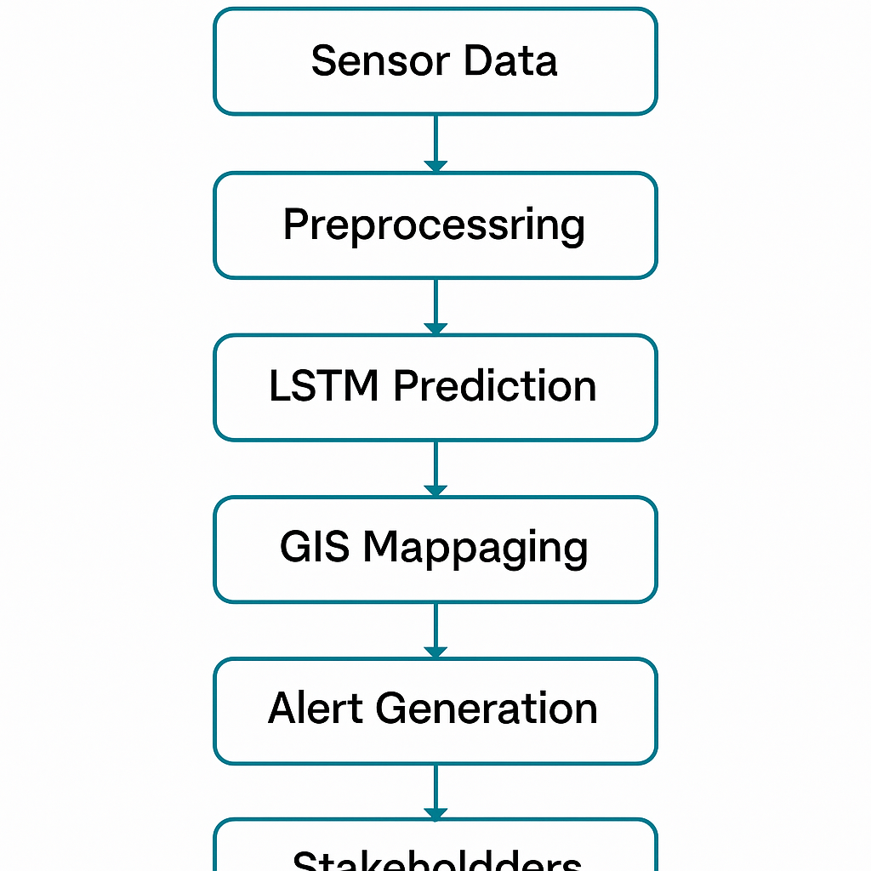

**Fig.9.:** Workflow of the Project

The implementation of the system is planned in a phased manner. Initially, all necessary hardware components, including Arduino boards, sensors, GSM modules, and buzzers, are assembled and configured for field data collection. Simultaneously, historical flood data and real-time sensor inputs are gathered to train and validate the LSTM-based prediction model. Software development proceeds on two fronts: the programming of microcontrollers for data acquisition and transmission, and the creation of machine learning pipelines for flood prediction. The GIS mapping module is developed in parallel to visualize predicted flood scenarios dynamically. Integration of the hardware and software modules follows, ensuring that data flows seamlessly from sensors to the prediction model and onward to the alert generation system. Testing is conducted under controlled environments to simulate flood scenarios and verify system response, calibration accuracy, and reliability. Upon successful testing, the system is deployed in selected flood-prone areas. Monitoring and maintenance protocols are established to ensure long-term operation, and stakeholder feedback is incorporated to enhance system usability and effectiveness.

**CHAPTER 4**

**RESULTS ANALYSIS AND VALIDATION**

**4.1. Implementation of Solutions**

The Flood Prediction and Alert System (FPAS) was developed and tested to evaluate its effectiveness in predicting and detecting flood situations. The system demonstrated a high degree of success both in hardware operation and software performance, including real-time alerting and spatial flood mapping.

The following outcomes were observed:

1. Hardware Testing and Implementation

* The Arduino UNO was used as the main controller, successfully interfaced with the HC-SR04 Ultrasonic sensor, the water level sensor, a 16x2 LCD display, and a buzzer.
* The setup enabled real-time detection of rising water levels.Circuit Diagram

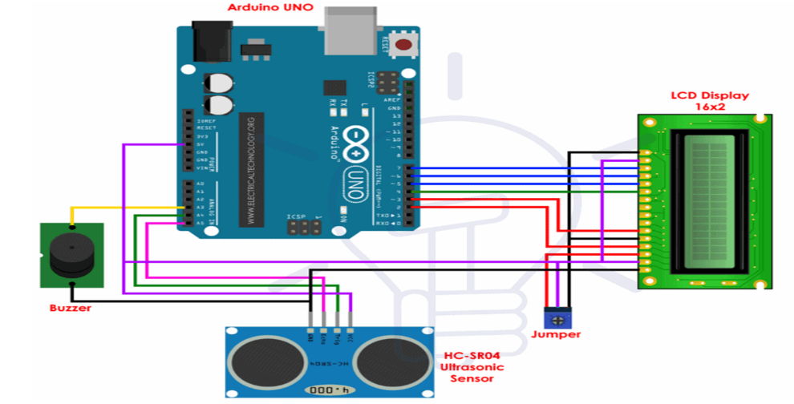

**Fig.10.:** Circuit Diagram of the Project

1. Components Used

* Arduino UNO:

Arduino is a free and open-source platform that is utilized for conducting research in the field of electronics. It can be effortlessly programmed, erased, and reprogrammed at any given moment. The market is flooded with various Arduino boards, such as the Arduino uno, Arduino nano, Arduino mega, Arduino Lilypad, and others, each with distinct specifications tailored to their specific applications. This board is typically programmed using Arduino IDE software, connected via a micro-USB cable. The atmega328 is equipped with a preinstalled boot loader, simplifying the process of uploading the code without the need for additional external hardware. It has extensive application in the creation of electronics projects or products. The C and C++ languages are utilized to program the board, which is incredibly simple to learn and utilize.

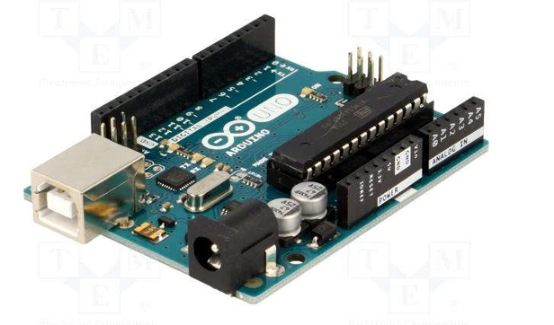

**Fig.11.:** Arduino UNO

* HC-SR04 Ultrasonic Sensor

The HC-SR04 ultrasonic sensor is a device that uses ultrasonic waves to measure distances without any human interaction. It operates on the same principle as radar and sonar, offering an efficient method for accurately measuring distances. In theory, the device can measure distances up to 450 cm, but in practice, it can measure distances ranging from 2 cm to 80 cm with an accuracy of 3 mm. It operates at a voltage of 5 volts, with a current of less than 15 ma and a frequency of 40 hertz. The hc-sr04 has a single transmitter and receiver integrated into its design. The formula for calculating distance is distance = speed x time, which is a fundamental concept that we all learned in school. The hc-sr04 sensor emits an ultrasonic wave into the surrounding atmosphere. If the reflected wave from an object within the sensor's range is detected, then the receiver of the sensor will receive the reflected wave in the air. In order to determine the distance using the formula, we need to have knowledge of the speed and time. We are aware that the average speed of the ultrasonic wave is approximately 330 meters per second. The passage of time is determined by the circuit constructed on the microcontroller. The echo pin reaches its peak during the duration of the ultrasonic wave's journey back to the receiver. By doing so, we can determine the distance between the object and the hc-sr04 ultrasonic sensor.

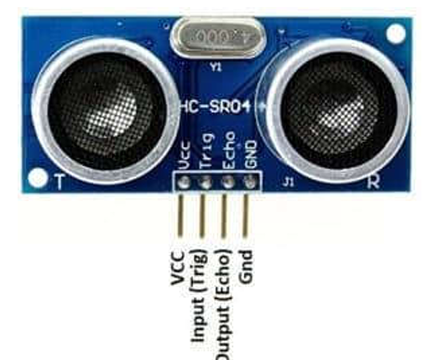

**Fig.12.:** Ultrasonic Sensor (HC-SR04)

* Water Level Sensor

The water level sensor is a device that measures the liquid level in a fixed container that is too high or too low. According to the method of measuring the liquid level, it can be divided into two types: contact type and non-contact type. The input type water level transmitter we call is a contact measurement, which converts the height of the liquid level into an electrical signal for output. It is currently a widely used water level transmitter. The working principle of the water level sensor is that when it is put into a certain depth in the liquid to be measured, the pressure on the sensor’s front surface is converted into the liquid level height. The calculation formula is Ρ=ρ.g.H+Po, in the formula P is the pressure on the liquid surface of the sensor, ρ is the density of the liquid to be measured, g is the local acceleration of gravity, Po is the atmospheric pressure on the liquid surface, and H is the depth at which the sensor drops into the liquid.

The level sensor is a device designed to monitor and measure liquid (and sometimes solid) levels. When the liquid level is detected, the sensor converts the sensed data into an electrical signal. Level sensors are mainly used for monitoring reservoirs, oil tanks or rivers.

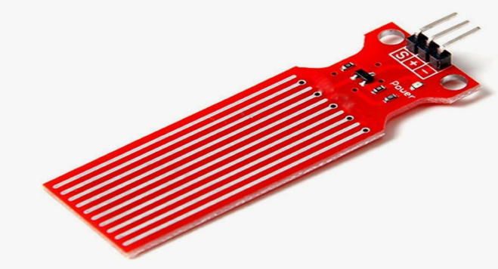

**Fig.13.:** Water Level Sensor

* 16x2 LCD Display

Connecting a 16 x 2 LCD display to an Arduino Uno is a straightforward process. There are numerous types of lcds available in the market, but the one we are utilizing in this project is 162, indicating that it has two rows, and in each row, we can display 16 characters. This module contains a driver from Hitachi, specifically the HD44780, which facilitates communication and interaction with the microcontrollers. This LCD can operate in both 4-bit and 8-bit modes. In 4-bit mode, only four data pins are needed to establish a connection between the lcd and the microcontroller, while in 8-bit mode, eight data pins are necessary. We will utilize 4-bit mode for this circuit since it requires fewer wires and simplifies the overall design. Let's examine the pin description of the LCD.

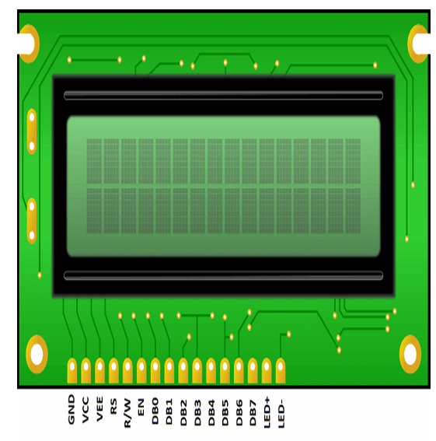

**Fig.14.:** 16x2 LCD Display Module

* Buzzer

The buzzer is a sound-emitting device similar to a beeper or buzzer. It could be electrical-mechanical, piezoelectric, or mechanical in nature. The primary purpose of this is to transform the audio signal into audible sound. Typically, it is powered by direct current voltage and employed in a range of devices such as timers, alarm systems, printers, alarms, and computers. Depending on the design, it can produce diverse sounds including alarms, music, bells, and sirens. Buzzers typically operate using piezoelectric or electromagnetic principles and can be programmed to emit sound at different frequencies and durations based on the severity or type of alert. They are easy to integrate with microcontrollers such as Arduino, NodeMCU, or Raspberry Pi, and can be triggered through digital output pins when flood conditions are detected.

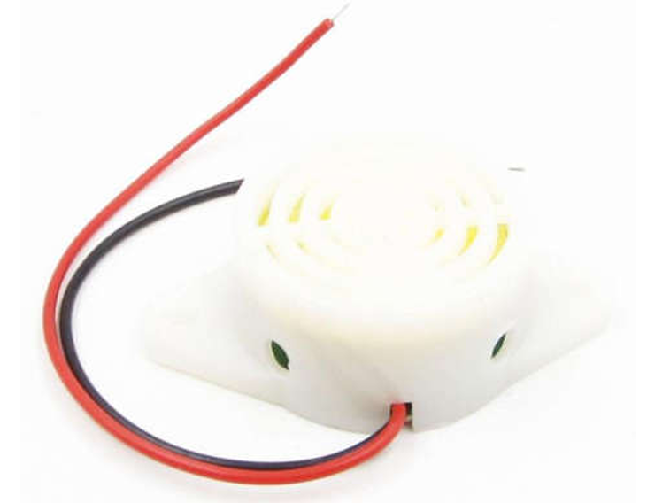

**Fig.15.:** Buzzer

* GSM-900 Module

The GSM 900 module is a wireless communication device that operates in the 900 MHz frequency band of the Global System for Mobile Communications (GSM) standard. GSM, originally developed to create a unified cellular communication system across Europe, has become one of the most widely adopted 2G mobile communication standards across the world. The 900 MHz band specifically is primarily used in Asia, Europe, Africa, and many other parts of the world. This module provides the ability to send and receive text messages (SMS), make and receive voice calls, and access mobile data services like GPRS (General Packet Radio Service) in embedded systems and microcontroller-based projects.

In terms of operation, the GSM 900 module connects to a mobile network operator's infrastructure through a SIM card inserted into the device. Once powered on, the module automatically searches for and connects to the strongest GSM network available. It establishes a communication link by registering itself with the cellular network, obtaining necessary network permissions such as signal synchronization and authentication through the mobile carrier's system.

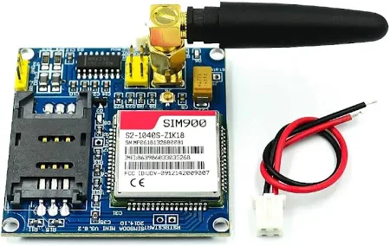

**Fig.16.:** GSM-900

* EXPERIMENTAL ANALYSIS

An Flood disaster management system has been proposed adapt new techniques successfully, could reduce the chances of losses of human lives as well as damage. This section shows some test results gathered during

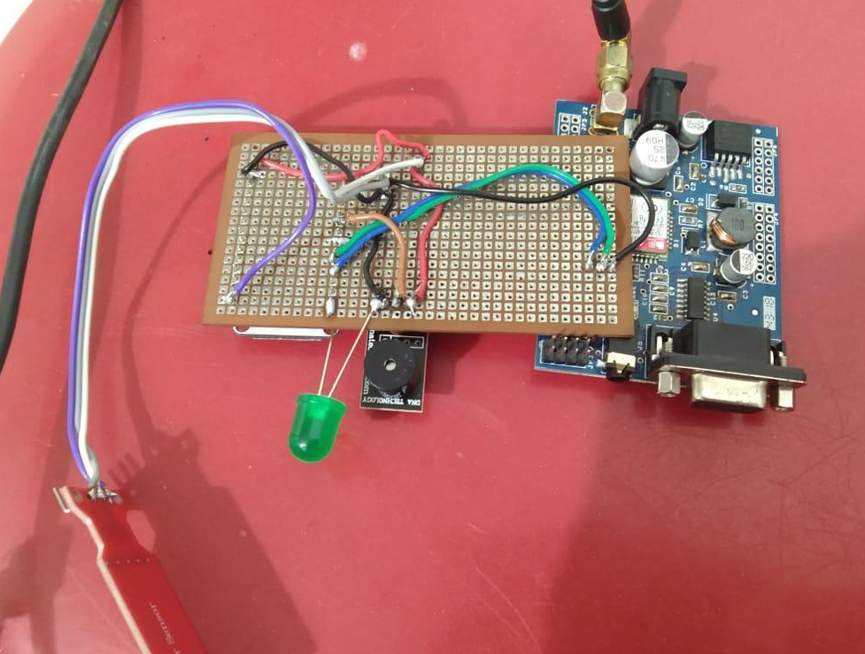

**Fig.17.:** Practical Representation of the Project

the experiments, stands in support of the claims made in the earlier sections. Figure shows a real-time time domain plot from the load balancer. The plot is of the average utilization data from 4 different cloud instances taking requests from rescue.

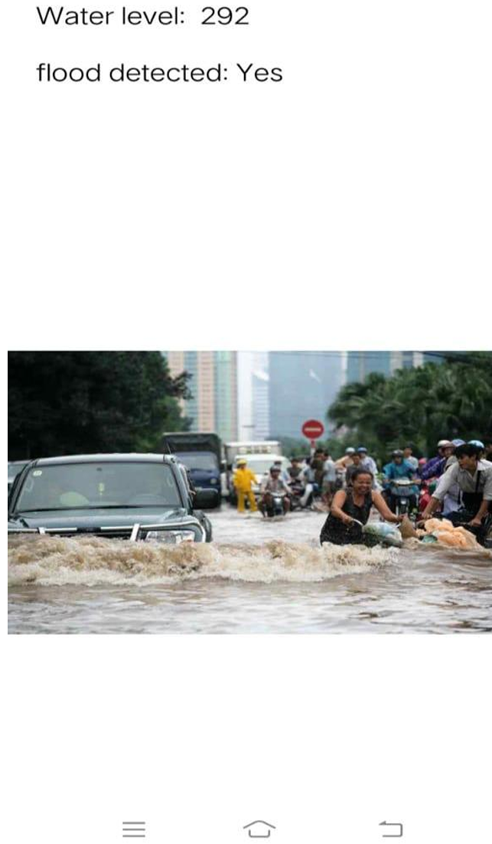

**Fig.18.:** Flood Detection Screen

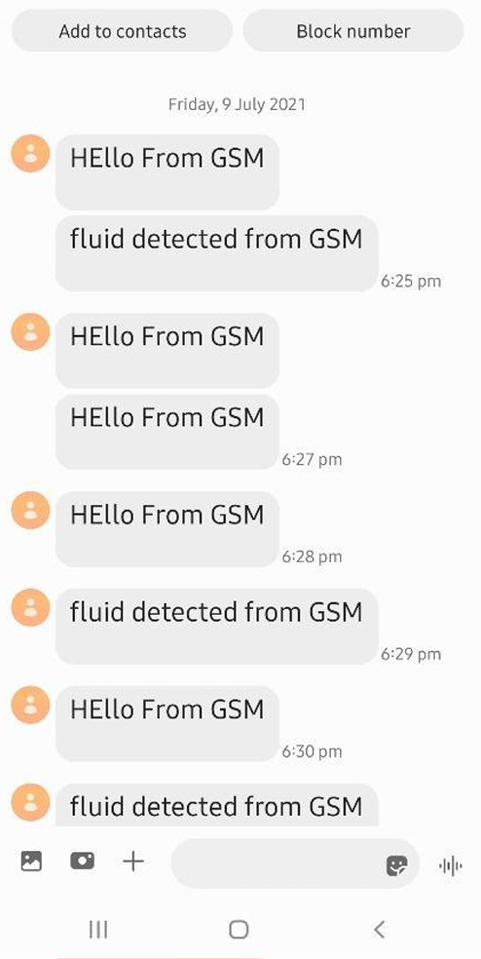

**Fig.19.:** Alert System

**CHAPTER 5**

**CONCLUSION AND FUTURE WORK**

* 1. **CONCLUSION**

The **Flood Prediction and Alert System** developed in this project offers a reliable and innovative solution to the ever-growing challenge of flood disasters. By integrating real-time environmental data, machine learning models, and GIS-based visualization tools, the system is capable of predicting potential flood risks with commendable accuracy. The methodology employed — from extensive data collection and preprocessing to model development and system deployment — highlights a structured and scientific approach to solving a critical societal problem.

The system not only predicts flood occurrences but also ensures that timely alerts are communicated effectively through various channels such as SMS, mobile notifications, and web dashboards. The deployment of IoT-based sensors further enhances real-time monitoring capabilities, providing critical inputs for immediate action. The mobile application and web portal created under this project provide easy accessibility for both authorities and the general public, thereby strengthening disaster preparedness at multiple levels.

In summary, the Flood Prediction and Alert System successfully meets its primary objectives of early flood detection, rapid alert dissemination, and user-friendly accessibility. It represents a significant step toward modernizing disaster management practices by incorporating data-driven and technology-based solutions, ultimately contributing to saving lives, protecting infrastructure, and reducing economic losses in flood-prone areas.

**Future Scope**

While the current system fulfills its intended goals, there are numerous opportunities for future enhancement and expansion. Incorporating additional data sources such as satellite imagery, snowmelt data, and drone-based local surveys could further improve the system’s prediction capabilities. The development of more advanced deep learning models, such as Convolutional LSTM networks, could enable more accurate modelling of complex flood patterns over both time and space.

Expanding the GIS component to include real-time, high-resolution flood maps would offer users a more detailed understanding of evolving flood risks. Moreover, transforming the platform into a multi-hazard early warning system by integrating forecasts for related events such as landslides and cyclones could significantly increase its utility.

Enhancing the alert system by including voice call-based notifications and mass media broadcasts would make the system more inclusive, especially for populations in remote or underserved areas. Migrating the system infrastructure to cloud-based platforms would ensure greater scalability, flexibility, and resilience against technical failures, allowing it to serve larger geographic areas with minimal downtime.

There is also a strong potential for the system’s integration with governmental disaster response agencies, enabling its use in formulating emergency response plans and urban development policies. Promoting community participation through user-reported flood observations can create a dynamic feedback loop, making the system smarter and more responsive with each event.

In addition, continuous learning mechanisms should be incorporated so that the predictive models evolve over time based on new flood data, improving their accuracy and reliability. Finally, research into the use of low-power, sustainable sensor networks could enhance the system’s performance in rural and infrastructure-limited settings, ensuring uninterrupted real-time monitoring.

The evolution of this system into a national or even global flood risk management platform could have a transformative impact, helping to create resilient communities capable of mitigating the devastating effects of climate change-driven natural disasters.

**REFERENCES**

[1] Z. W. Kundzewicz and Z. Kaczmarek, "Coping with hydrological extremes," *Water International*, vol. 25, no. 2, pp. 252–262, 2000.

[2] L. Alfieri, P. Burek, L. Feyen, and G. Forzieri, "Global warming increases the risk of river floods," *Nature Climate Change*, vol. 5, no. 6, pp. 588–594, 2015.

[3] S. K. Jain, R. D. Singh, M. K. Jain, and A. K. Lohani, "Deluge, floods, and flood forecasting," *Current Science*, vol. 88, no. 3, pp. 366–377, 2005.

[4] S. Ahmad, A. Kalra, and H. Stephen, "Estimating soil moisture using remote sensing data: A machine learning approach," *Advances in Water Resources*, vol. 33, no. 1, pp. 69–80, 2010.

[5] A. Bhardwaj and M. Lal, "Flood Prediction Using Machine Learning Algorithms: A Review," *International Journal of Engineering Research & Technology (IJERT)*, vol. 9, no. 5, pp. 612–616, 2020.

[6] T. DeGroeve and J. Thielen, "Flood monitoring through satellite remote sensing and hydrological modeling," *International Journal of Remote Sensing*, vol. 27, no. 20, pp. 4285–4301, 2006.

[7] World Meteorological Organization (WMO), *Manual on Flood Forecasting and Warning*, WMO-No. 1072, Geneva, Switzerland, 2011.

[8] M. A. Ghorbani, M. Gorji, S. Farzin, and S. Ghasemi, "Application of artificial intelligence methods in flood forecasting: A comprehensive review," *Natural Hazards*, vol. 99, no. 1, pp. 543–565, 2019.

[9] Government of India, Ministry of Jal Shakti, *Comprehensive Flood Management Guidelines*, 2019. [Online]. Available: [http://mowr.gov.in](http://mowr.gov.in/)

[10] F. Pappenberger, J. Thielen, and H. L. Cloke, "Advances in flood forecasting," *International Journal of River Basin Management*, vol. 9, no. 1, pp. 1–4, 2011.

[11] NOAA National Weather Service, "Flood Forecasting Tools and Technologies," 2023. [Online]. Available: [https://www.weather.gov](https://www.weather.gov/)

[12] J. A. Smith, M. L. Baeck, and M. Steiner, "Catastrophic rainfall and flooding in Texas: The October 1998 event," *Journal of Hydrometeorology*, vol. 1, no. 1, pp. 5–25, 2000.

[13] ESRI, "Using GIS for flood risk management," 2020. [Online]. Available: [https://www.esri.com](https://www.esri.com/)

[14] M. Tarek, F. P. Brissette, and R. Arsenault, "Comparison of flood forecasting models: Statistical vs machine learning," *Journal of Hydrology*, vol. 580, p. 124321, 2020.

[15] QGIS Development Team, *QGIS Geographic Information System*, Open Source Geospatial Foundation Project, 2022. [Online]. Available: [http://qgis.org](http://qgis.org/)

[16] Amazon Web Services (AWS), "Disaster Response Solutions on AWS Cloud," 2021. [Online]. Available: <https://aws.amazon.com/solutions>

[17] Kaggle, "Flood Prediction Dataset," 2023. [Online]. Available: https://www.kaggle.com/datasets

[18] IPCC, *Climate Change 2022: Impacts, Adaptation and Vulnerability*, Cambridge University Press, 2022.

[19] United Nations Office for Disaster Risk Reduction (UNDRR), *Global Assessment Report on Disaster Risk Reduction*, 2022. [Online]. Available: [https://www.undrr.org](https://www.undrr.org/)

[20] D. L. Shrestha, D. E. Robertson, and Q. J. Wang, "A Bayesian hierarchical model for blending forecasts from multiple models for seasonal streamflow prediction," *Water Resources Research*, vol. 51, no. 10, pp. 8217–8233, 2015.